**Course One**

# Foundations of Data Science



# Instructions

Use this PACE strategy document to record decisions and reflections as you work through this end-of-course project. You can use this document as a guide to consider your responses and reflections at different stages of the data analytical process. Additionally, the PACE strategy documents can be used as a resource when working on future projects.

# Course Project Recap

Regardless of which track you have chosen to complete, your goals for this project are:

* ~~Complete the PACE Strategy Document to plan your project while considering your audience members, teammates, key milestones, and overall project goal.~~
* ~~Create a project proposal for the data team.~~

# Relevant Interview Questions

Completing this end-of-course project will empower you to respond to the following interview topics:

* As a new member of a data analytics team, what steps could you take to get 'up to speed' with a current project? What steps would you take? Who would you like to meet with?
* How would you plan an analytics project?
* What steps would you take to translate a business question to an analytical solution?
* Why is actively managing data an important part of a data analytics team's responsibilities?
* What are some considerations you might need to be mindful of when reporting results?

**Reference Guide**

This project has three tasks; the following visual identifies how the stages of PACE are incorporated across those tasks.

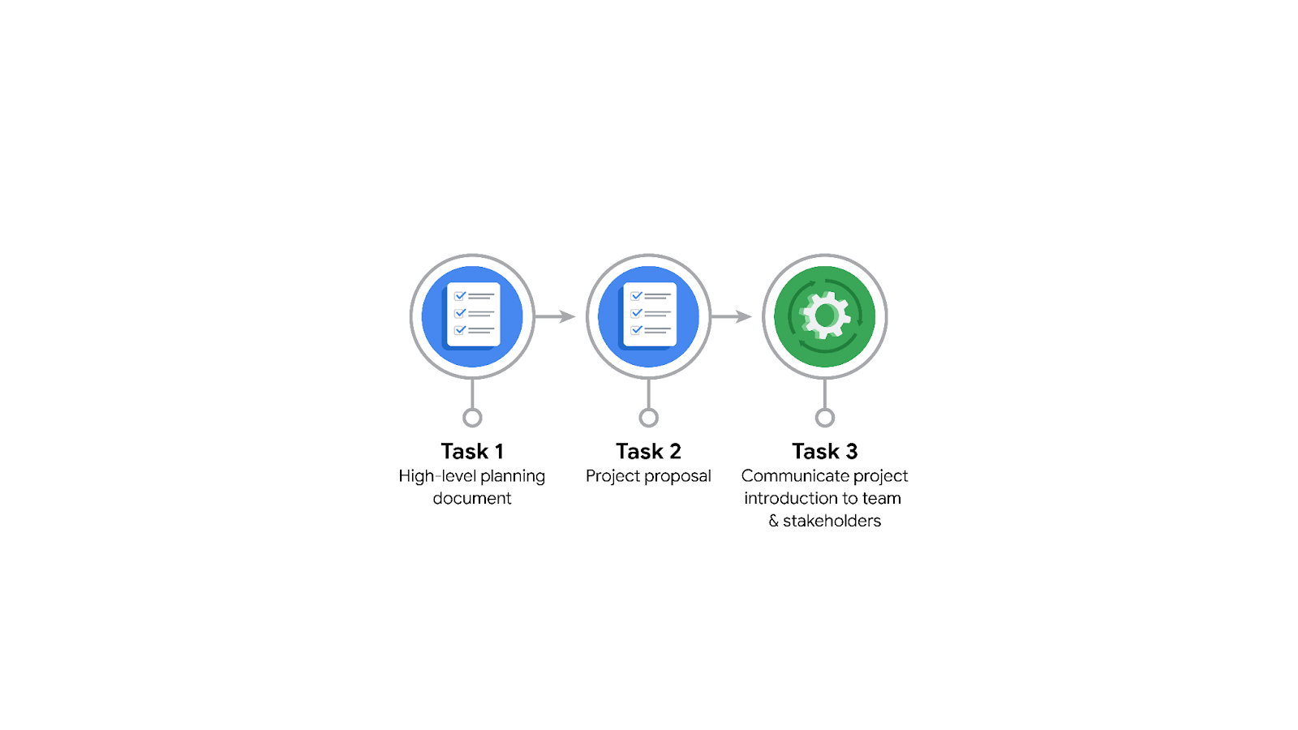

**Data Project Questions & Considerations**

**PACE: Plan Stage**

* Who is your audience for this project?

The audience is stakeholders in the company. Some including Harriet Hadzic - Director of Data Analysis, Emrick Larson - Finance and Administration Department Head, & Ursula Sayo - Operations Manager.

* What are you trying to solve or accomplish? And, what do you anticipate the impact of this work will be on the larger needs of the client?

We are trying to answer the who, why and when do users of the Waze app churn. Knowing these things will give insights to the company about user churn so actions can be taken to help minimize it. Then we are going to develop a machine learning model that predicts user churn. This will then be used to help optimize the user retention strategy.

* What questions need to be asked or answered?

What computing software will be used? What data points are available and useful? When were there any significant peaks or valleys in user churn? Were there any Waze programs in place at those times that could have affected the churn rate? Are there any significant outside forces, i.e. a google maps software update that we need to be aware of that could have led to higher churn?

* What resources are required to complete this project?

Effective communication. A well managed data system. Teamwork. Python. Data visualizations.

* What are the deliverables that will need to be created over the course of this project?

Answers about user churn listed above. Regression model. A machine learning model to predict churn. Data visuals. Stakeholder presentation.

## 

## **THE PACE WORKFLOW**

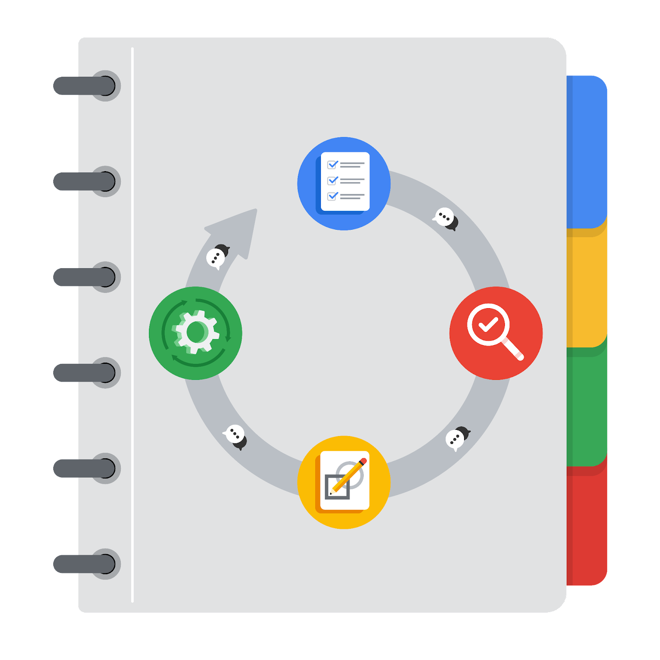

**[Alt-text: The PACE Workflow with the four stages in a circle: plan, analyze, construct, and execute.]**

You have been asked to demonstrate for the company's data team how you would use the PACE workflow to organize and classify tasks for the upcoming project. Select a PACE stage from the dropdown buttons. A few tasks involve more than one stage of the PACE workflow. Additionally, not every workplace scenario will require every task. Refer back to the Course 1 end-of-course portfolio project overview reading if you need more information about the tasks within the project.

### 

### **Project tasks**

Following are a group of tasks your company’s data team has determined need to be completed within this project. The data analysis manager has asked you to organize these tasks in preparation for the project proposal document. First, identify which stage of the PACE workflow each task would best fit under using the drop down menu. Next, give an explanation of why you selected the stage for each task. Review the following readings to help guide your selections and explanation: The PACE stages and Communicate objectives with a project proposal. You will later reorder these tasks within a project proposal.

1. **Evaluating the model: Execute**

Why did you select this stage for this task?

After the model has been constructed, this stage evaluate its effectiveness.

1. **Conduct hypothesis testing: Analyze** **and** **Construct**

Why did you select these stages for this task?

During the analysis stage we will use EDA to create a hypothesis. During the construct stage we will test the hypothesis.

1. **Begin exploring the data: Analyze**

Why did you select this stage for this task?

This stage is all about EDA.

1. **Data exploration and cleaning: Plan** **and Analyze**

Why did you select these stages for this task?

We will plan on what data needs to be collected and explored then clean it during the analysis phase.

1. **Establish structure for project workflow (PACE): Plan**

Why did you select this stage for this task?

Establishing project workflow is planning.

1. **Communicate final insights with stakeholders: Execute**

Why did you select this stage for this task?

Final step final insights, this stage includes sharing our findings.

1. **Compute descriptive statistics: Analyze**

Why did you select this stage for this task?

We will use descriptive statistics to help us create the ML model.

1. **Visualization building: Analyze and Construct**

Why did you select these stages for this task?

The construct stage is the building stage, then we will execute the visuals to the stakeholders and gain recommendations.

1. **Write a project proposal: Plan**

Why did you select this stage for this task?

We are building out the project at this stage, this includes writing a project proposal.

1. **Build a regression model: Analyze and Construct**

Why did you select this stage for this task?

The analyze stage will sort and clean the data to be ready to be used for this construction of the model.

1. **Compile summary information about the data: Analyze**

Why did you select this stage for this task?

Inspecting the dataset.

1. **Build machine learning model: Construct**

Why did you select this stage for this task?

This stage is all about building.